**4. HALL EFFECT**

**Objective:**

To study the Hall effect and to determine the hall coefficient, charge carrier concentration (n=density) and carrier mobility of given semiconductor material using Hall set up.

**Apparatus Required:**

Gauss and Tesla meter , Measurement unit, Constant current power supply, Electromagnet, Hall probe, In-As probe etc.

**Theory and Formula used:**

If an electric current flow through a conductor in a magnetic field, the magnetic field exerts a transverse force on the moving charge carriers which tends to push them to one side of the conductor. This is most evident in a thin flat conductor as illustrated. A build-up of charge at the sides of the conductors will balance this magnetic influence, producing a measurable voltage between the two sides of the conductor. The presence of this measurable transverse voltage is called the Hall Effect after E. H. Hall who discovered it in 1879.

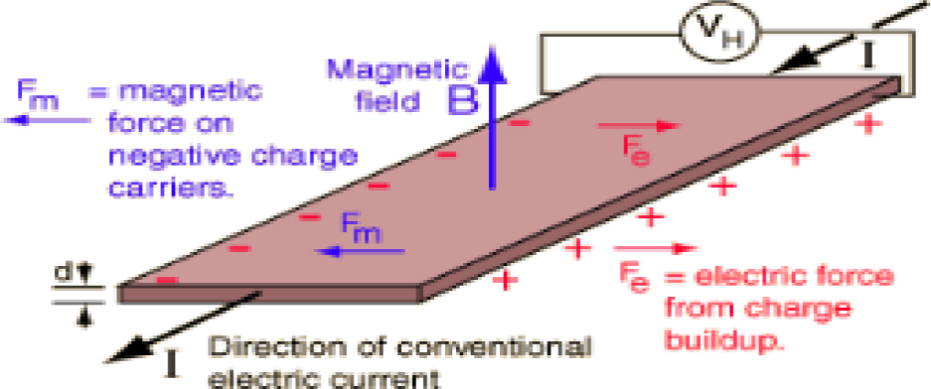

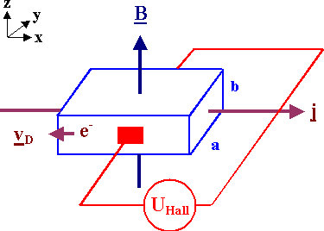

**Fig. Schematic diagram and circuit of Hall effect.**

The hall coefficient is given by

Where,

*V d RH*  *IB*

........ (1)

VH is the hall voltage, d is the thickness of the sample, I is the probe current, B is the applied magnetic field, n is the charge carrier density and e is the electronic charge. The value of VH/I can be calculated by plotting the graph between I and VH.

*H*

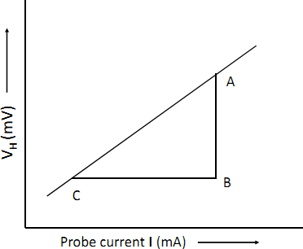

**Figure 1**

This graph will be a straight line as shown in Figure 1 and the slope will be given as:

Slope =

*AB*

*BC* 

*RH B*

*d*

*AB d*

Hence,

*RH*  *BC*  *B*

The charge carrier density n can be calculated as:

1

*n*  (2)

| *RH* | *e*

We know that carrier mobility is the velocity of current carrying particle per unit electric field and it is related with hall coefficient as

**  * RH*

----(3)

Where,  = 1/ is the conductivity and  is the resistivity of the sample.

**Procedure:**

1. Take the Constant Current Power Supply. Keep the potentiometer at fully anticlockwise position. Connect electromagnet with Constant Current power supply such that two coils of electromagnet are in series i.e. the direction of current in both the coils should be same otherwise little or no magnetic field would result.
2. Keep the Poles of electromagnet at a distance of 20 mm.
3. Take Gauss & Tesla meter from the set of Hall Effect Trainer.
4. Connect In-As probe and switch on the Gauss & Tesla meter.
5. Set the reading on the display of Gauss & Tesla meter to Zero.
6. Switch on the constant current power supply. Increase the current 4 ampere and note the corresponding magnetic field from Gauss & Tesla meter. Take the reading of magnetic field by keeping In-As probe in between the poles. From one side of the probe B will be positive and from another side it will be negative. Tabulate the readings as shown in the following observation table 1.
7. Now take the measurement unit and set the switch position as follows:
   1. Heater current potentiometer at minimum position (anticlockwise position).
   2. Probe current potentiometer at minimum position (anticlockwise position).
8. Connect the given semiconductor (Ge) sample in the given probe socket (NV622).
9. Switch on the Constant Current Power supply and set the value of current to 4 A. Note the corresponding magnetic field from table 1.
10. Switch on the Measurement unit and set the probe current to 1mA.
11. There may be some voltage reading even outside the magnetic field. This is due to imperfect arrangement of the four contact of the hall probe and generally known as the “Zero field potential” or offset voltage. This error should be subtracted from the hall voltage reading as we consider it as a reference.
12. Now place the Hall probe between magnetic poles using stand such that the magnetic and electric field should be perpendicular to each other.
13. Measure & record the Hall voltage on the measurement unit display.
14. The Hall voltage should be measured for both sides of probe.
15. Subtract Zero field potential and take the mean of both sides Hall voltages readings. This is Hall voltage VH.
16. plot the graph between probe current (I) and hall voltage (VH) and calculate the slop.
17. Now put the value of slop (VH/I) in equation 1 and calculate hall coefficient. From equations 2 and 3, the charge density (n) and the charge mobility (µ) can be calculated.

**Observations:**

**Table 1.**

|  |  |  |  |
| --- | --- | --- | --- |
| IB (A) (X) | Magnetic field (B+) (from  one side of probe) | Magnetic field (B-) (from  another side of probe) | Mean= (B+- B-)/2  B(Tesla) (Y) |
| 1.0 A | 0.1482 gauss | -0.1482 | 0.1482 |
| 1.50A | 0.2223 | -0.2223 | 0.2223 |
| 2.0A | 0.2964 | -0.2964 | 0.2964 |
| 2.50 | 0.3706 |  | .3706 |
| 3.0 | 0.4447 |  |  |
| 3.5 | 0.5188 |  |  |
| 4.0 | 0.5929 |  |  |
| 4.5 | 0.6670 |  |  |
| 5.0 | 0.7411 | -0.7411 | 0.7411 |

One **gauss** corresponds to 10-4 **tesla**

IB = 5.0 A, B = 0.7411x10-4 Tesla (From table 1)

**Table 2.**

|  |  |  |  |  |  |  |
| --- | --- | --- | --- | --- | --- | --- |
| Probe Current I (mA) | Zero field Potential (offset voltage)  Vzero(mV) | Observed Hall voltage for one side (V+H)  (mV) | Observed Hall voltage for Second side  (V-H ) (mV) | Actual Hall voltage for one side  (V+=V+H -V zero) (mV) | Actual Hall voltage for Second side  (V-= V-H -V zero) (mV) | Mean Hall voltage  VH = (V+ -V-)/2 (mV) |
| 1.0 |  | 23.005 |  |  |  | 23.005 |
| 1.5 |  | 34.507 |  |  |  | 34.507 |
| 2.0 |  | 46.009 |  |  |  | 46.009 |
| 2.50 |  | 57.511 |  |  |  | 57.511 |
| 3.0 |  | 69.014 |  |  |  | 69.014 |
| 3.5 |  | 80.516 |  |  |  | 80.516 |
| 4.0 |  | 92.018 |  |  |  | 92.018 |
| 4.5 |  | 103.520 |  |  |  | 103.520 |
| 5.0 |  | 115.023 |  |  |  | 115.023 |
|  |  |  |  |  |  |  |
|  |  |  |  |  |  |  |

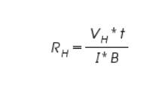

**Calculations:**

Thickness of the material (d) = 0.5mm-= 0.5x10-3 m

Electron Charge (e) = ............................

Magnetic field (B) = ............................

Slope =

*AB*

*BC* 

*RH B*

*d*

*AB d*

Hence,

*RH*  *BC*  *B*

**= 23.004x0.5x10‑3/** 0.7411, **RH=1.55x 10-2**

Calculation for charge carrier density n:

1

*n*  | *R*

*H*

=1/1.6x10-19xRH ...........................

| *e*

Given, Resistivity of the material () = **0.47 Ohm -m**

Conductivity  = 1/  hm-1m-1

Calculation for charge mobility:

****  * RH* =** m2/volt-sec

**Results:**

The Hall coefficient (RH) = m3 coulomb

/

The value of charge carrier density (n) = ……………………….. m-3

The value of charge mobility (µ) = m2/volt-sec

**Precautions and sources of error:**

* 1. Hall probe should be placed in the middle of the poles of electromagnet.
  2. While connecting the electromagnet with constant current source the direction of current should be same in both the coils.
  3. In Gauss and Tesla meter, zero reading should be set on display by Zero Adjust Potentiometer.
  4. Zero field potential will be subtracted from Hall voltage reading.